
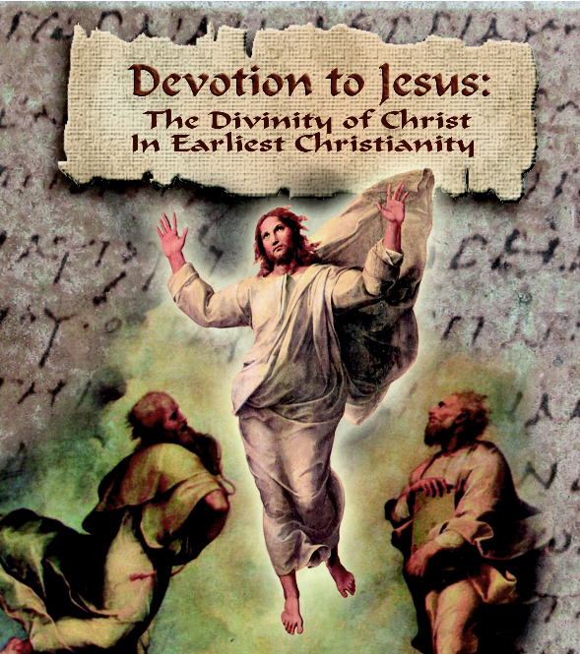

Devotion to Jesus
The Divinity of Christ
In Earliest Christianity

With Dr. Larry Hurtado

Time:
Dates:
Location:

Interested? Please Contact:

Announcing an Exciting New Study Opportunity From Wesley Ministry Network:

When, where and why did people first believe in the divinity of Jesus?

These are the essential but also controversial questions addressed in this vitally important course.

Join renowned New Testament scholar Professor Larry Hurtado as he lays out the evidence and, in the process, clears away a mountain of popular misinformation.
Announcing an Exciting New Study Opportunity From Wesley Ministry Network:

Time:
Dates:
Location:

Interested? Please Contact:

Devotion to Jesus
The Divinity of Christ
In Earliest Christianity

With Dr. Larry Hurtado

When, where and why did people first believe in the divinity of Jesus?

These are the essential but also controversial questions addressed in this vitally important course.

Join renowned New Testament scholar Professor Larry Hurtado as he lays out the evidence and, in the process, clears away a mountain of popular misinformation.

